Sangala Mosaic User Guide
Sangala Mosaic is the Mosaic Design Tool you use to turn a photograph into a LEGO-tile mosaic you build by hand on a baseplate. You have chosen an animal — a crested crane, a buffalo, whatever is yours — and you have a picture of it. This guide takes you from that picture to a finished plan: the tiles laid out square by square, in the colors you actually own, with a parts list telling you how many of each to gather.
Everything runs in the browser. There is no install, no internet, and no machine to connect to — the mosaic is built by hand, so the tool's whole job is to hand you a plan you can follow.

1. The big picture
Every mosaic follows the same path:
Open a photo → frame the part you want → Build It! → tidy it by hand → read off the parts list.
The one idea that turns this from a toy into a build tool: Sangala maps your picture only to the tiles you actually have, and then tells you how many of each you will need. That idea runs through the whole guide — Section 3 is the one to read closely.

2. The screen
Sangala Mosaic has four regions, like a workbench:
- Menu bar (top) — Open a photo, and the ways of looking at your work: Compare, Transparent, and About.
- Tools (left edge) — the by-hand editing tools you use after building: Paint, Pick, and Erase.
- The workspace (center) — your working surface. Your photo (or photos) and the grid frame sit here; this is where you arrange what will become the mosaic.
- Build panel (right) — the green Build It! button and everything that shapes the result: the grid size, your tile palette, the baseplate, and the bill of materials (the parts list).
You never connect to anything — open a photo and you can start.

3. Build to the tiles you own (read this)
This is the heart of the tool. A mosaic is only buildable if it uses colors you actually have, in numbers you can gather.
- The palette is your inventory. Down the right side is a row of real LEGO tile colors. Click a color to turn it off (you don't own it) or back on (you do). Sangala builds using only the colors that are on — so the picture on screen is always something you could really build.
- The parts list is your gather list. After you build, the bill of materials at the bottom of the panel counts every tile by color — “47 dark gray, 23 white, 8 red…” — and totals them. That is exactly what you carry to the tile bin.
So before you build, set the palette to match your box of tiles. Everything else in this guide serves this one idea.

4. Open a photo (and build a scene)
- Click Open (or drag a picture onto the workspace). Sangala accepts .png and .jpg.
- The photo drops onto the workspace at a comfortable size. Drag its body to move it; drag a corner handle to resize it (the shape is kept, so it never stretches). Press Delete to remove a selected photo.
- Open again to add another picture. Each Open adds a layer, so you can build a scene — mountains behind, your animal in front — and turn the whole composite into one mosaic.
Layer order (which picture is in front). Select a picture to open its panel on the right, then use the layer controls there to send it forward or back, so the foreground animal sits on top of the background.

5. Remove the background
To lift your animal off its background so only the animal becomes tiles:
- Select the picture.
- In its panel, turn on Remove background. Sangala clears the backdrop from the edges inward and leaves the subject — keeping interior whites (a crane's white belly stays; only the true background goes).
- The original is never lost. Turn Remove background off to bring the backdrop back.
With the background removed, the empty area around your animal becomes empty cells in the mosaic (or bare baseplate), not tiles — so you don't spend tiles on sky you never wanted.

6. The grid — framing your mosaic
The grid frame is the box on the workspace that decides what becomes the mosaic and how fine it is. Whatever falls inside the frame is what gets built.
- Move it — drag the frame's border. Resize it — drag a corner (the cells stay square).
- Across and Down — in the Build panel's Grid section, set how many tiles wide and tall. The standard baseplate is 32 × 32, and that is the default. The readout shows the real size — 32 × 32 tiles is about 256 mm ≈ 10 inches — so you know how big the finished piece will be.
- Show grid — toggles the cell lines and the row and column labels (numbers across the top, letters down the side) that you follow while building.
Fewer tiles across make bigger, blockier tiles and a coarser picture; more make a finer picture that needs more, smaller tiles. Slide the frame over the part of your animal you most want to capture.
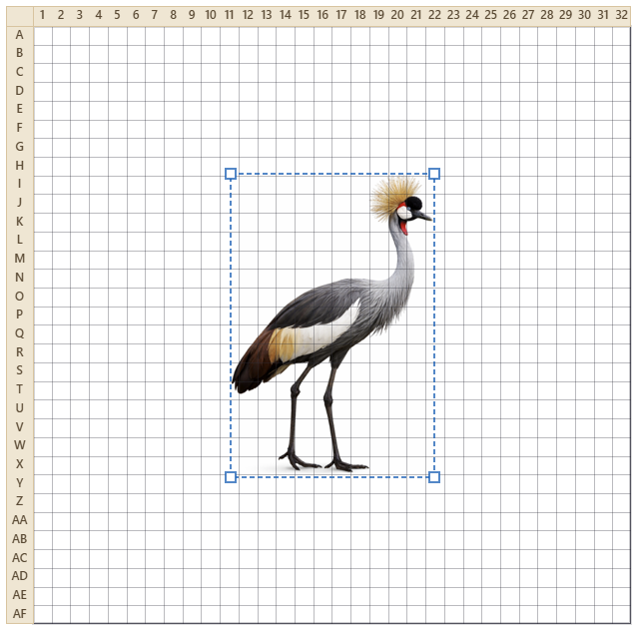
Figure 1. A photo positioned under the grid — whatever falls inside the frame becomes the mosaic.

7. Build It!
Press the green Build It! button and Sangala maps the framed picture to your owned tiles, cell by cell, and shows the result on its baseplate. Compare and Transparent let you check it against the photo.
A few controls (in the Options part of the panel) shape the result; change any one and the mosaic re-maps at once:
- Ignore background (on by default) — treats the removed or empty background as empty cells, so thin parts like legs survive instead of being outvoted by a sea of sky.
- Colors — how many different tile colors to reduce the picture to. A low number gives a bolder, simpler mosaic; a high number gives more shading. Sangala always snaps these to your nearest owned colors.
- Clean up — gently fills single-tile holes and drops lone stray tiles, so the mosaic reads cleanly without erasing real detail.
- Contrast and Brightness — adjust these if the picture is going muddy; a little more contrast separates the colors before they are reduced.
If the result is close but not perfect, that is expected — the last touch-ups are done by hand (Section 10).
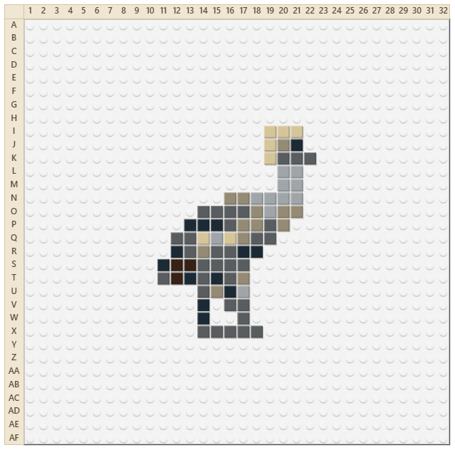
Figure 2. The finished mosaic on its baseplate.

8. The baseplate
The built mosaic sits on a baseplate — the studded plate the tiles snap onto — so you see it the way it will really look.
- Baseplate color — choose from the Baseplate swatches. These are limited to the colors LEGO actually sells baseplates in (White, Green, Gray, Blue, Sand, Black, Red), so your plan stays realistic. White is the default.
- Show or hide — the Shown / Hidden button hides the plate for a clean, chart-like view of just the tiles (handy for reading the pattern). With the plate shown, the studs mark the grid; hide it and the cell lines return so empty cells stay clear.

9. Seeing your work: Compare and Transparent
Two ways to check the mosaic against your photo, both in the menu bar:
- Compare — show the photo and the mosaic side by side, so you can judge the likeness without flipping back and forth.
- Transparent — make the tiles translucent so the photo shows through underneath. Turn this on while painting (Section 10) to trace the picture tile by tile.
Click the workspace to leave a result view and go back to arranging.
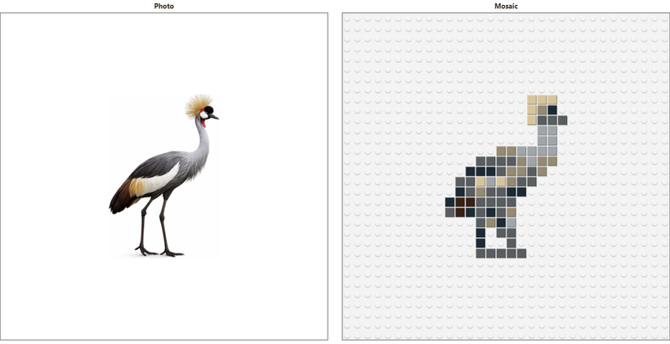
Figure 3. Compare places the photo beside the mosaic.
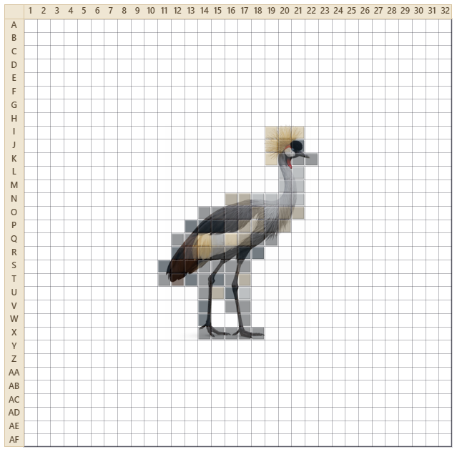
Figure 4. Transparent makes the tiles translucent so the photo shows through.

10. Fixing it by hand: Paint, Pick, Erase
Automatic mapping gets you most of the way; the eye, a beak, a clean edge are placed by hand. After you build, use the tools on the left rail:
- Paint — click a color in the palette, then click or drag across cells to set them to that color. Right-click a cell to clear it.
- Pick — click a cell to grab its color, then keep painting with it.
- Erase — click or drag to clear cells back to empty (the baseplate shows through).
Undo is there. Ctrl-Z undoes your last stroke — a whole dragged line comes back in one press — and Ctrl-Y (or Ctrl-Shift-Z) redoes it. Rebuilding, or changing the photo, starts fresh, so save your hand edits for last.

11. The parts list (bill of materials)
At the bottom of the Build panel, the bill of materials lists every tile color in your mosaic with the count of each, sorted most-used first, and the grand total. This is your gather-and-build list — and because Sangala only ever uses colors you turned on, every line is a color you have.

12. Quick reference
I want to… | Do this
Add a photo | Open, or drag a picture onto the workspace
Move or resize a photo | Drag its body, or a corner handle
Build a scene | Open more pictures; set which is in front with the layer controls
Drop the background | Select the photo, turn on Remove background
Choose what becomes the mosaic | Drag or resize the grid frame over it
Set the mosaic's size | Across and Down in the Grid section
Say which tiles you own | Click colors in the palette to turn them on or off
Make the mosaic | Build It!
Simplify or add shading | The Colors slider
Change the baseplate | Baseplate swatches; Shown / Hidden to hide it
Compare with the photo | Compare or Transparent
Fix a cell by hand | Paint, Pick, or Erase; Ctrl-Z to undo
Get the parts list | Read the bill of materials at the bottom

13. Which tools for which task
- Turning your animal into a mosaic: Open the photo, Remove background, frame it with the grid, set your palette, Build It!, then finish the face and edges with Paint.
- A scene with a background: Open the background first and the animal second, set the layer order, frame the two together, then Build It! so both become one mosaic.
- Getting a clean likeness: build with a low Colors count for a bold read, turn on Transparent to trace the details, and Paint the eye and beak by hand.
- Planning the build: pick your Baseplate color, read the bill of materials for what to gather, and follow the numbered and lettered grid square by square.

